1. Core Thesis
The paper argues that Large Language Models (LLMs) are not epistemic agents, even though they often appear to reason or judge like humans. Their outputs are the result of statistical pattern completion, not genuine understanding, belief formation, or reasoning. This creates a structural condition called Epistemia, where linguistic plausibility replaces epistemic justification.
Epistemic agency is a conceptual tool for creating effective teaching methods that involve students taking accountability for their own learning and aligns with the broader emphasis on agency in modern education.
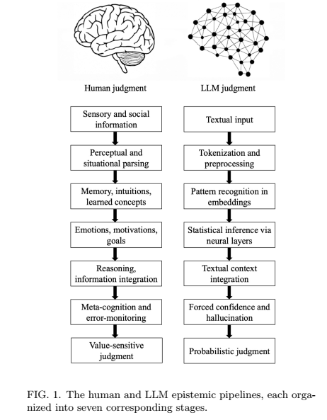

2. Central Claim
LLMs exhibit surface-level alignment with human reasoning but deep epistemic divergence. They produce fluent and convincing outputs without possessing:
- beliefs
- understanding
- causal reasoning
- epistemic responsibility
As a result, users experience the illusion of knowing without engaging in genuine judgment.

3. Core Concept: Epistemia
Epistemia is defined as:
A structural condition in which linguistic plausibility substitutes for epistemic evaluation.
Key properties:
- Answers appear authoritative without being grounded.
- Confidence replaces justification.
- Users receive conclusions without epistemic labor.
- Truth is replaced by statistical plausibility.
Epistemia is not user error or bias; it is architecturally produced by generative AI systems.

4. Seven Epistemological Fault Lines
The paper identifies seven structural divergences between human cognition and LLMs:

1. Grounding Fault
- Humans: Perceive the world through embodied, social, and sensory experience.
- LLMs: Operate only on text; meaning is reconstructed statistically.

2. Parsing Fault
- Humans: Parse situations holistically using perception and context.
- LLMs: Tokenize text mechanically, without semantic understanding.

3. Experience Fault
- Humans: Use episodic memory, intuitive physics, and social understanding.
- LLMs: Use statistical correlations in embeddings; no lived experience.

4. Motivation Fault
- Humans: Guided by emotions, goals, values, and survival motives.
- LLMs: Have no goals or values; only optimize probability distributions.

5. Causality Fault
- Humans: Reason using causal models and counterfactuals.
- LLMs: Rely on correlation, not causal understanding.

6. Metacognitive Fault
- Humans: Can detect uncertainty, errors, and withhold judgment.
- LLMs: Cannot know when they don’t know; hallucination is structural.

7. Value Fault
- Humans: Judgments involve responsibility, ethics, and consequences.
- LLMs: Outputs are probabilistic continuations without moral grounding.

5. Key Insight: Why LLMs Appear Intelligent
LLMs succeed because:
- They operate in high-probability regions of language.
- Fluency and confidence trigger human credibility heuristics.
- Users mistake linguistic coherence for epistemic reliability.
This creates a false sense of understanding, even when content is incorrect or unjustified.

6. Text Generation as a Statistical Process
- LLMs generate text as stochastic walks over high-dimensional probability graphs.
- There is no internal notion of truth, reference, or belief.
- “Hallucinations” are not errors but expected outcomes.
- Scaling improves fluency, not epistemic grounding.

7. Implications

A. Evaluation
- Standard benchmarks measure surface correctness, not epistemic validity.
- Need evaluation methods that test uncertainty handling, abstention, and causal reasoning.

B. Governance
- Risk lies not only in harmful outputs but in replacing human judgment.
- Generative systems should not be treated as epistemic authorities.
- Governance must focus on how outputs are used, not just what they say.

C. Epistemic Literacy
A new literacy is required to:
- Recognize when AI outputs simulate judgment.
- Distinguish plausibility from justification.
- Maintain human accountability in decision-making.

8. Core Conclusion
LLMs do not “know” anything in the human sense.
They generate plausible text without epistemic grounding.
As systems become more fluent, the danger increases, not because they are wrong more often, but because they appear right without being epistemically accountable.
This creates a new epistemic condition; Epistemia, where knowledge is replaced by linguistic performance.

